Parking Lot Practice

The following series of pages describe several exercises which you can practice by yourself or with a friend. The proper execution of these exercises will help you in various traffic situations. Do not attempt these exercises unless you can already perform basic skills such as using the clutch and throttle correctly, shifting and riding in a straight line. If you do not have these basic skills, be sure to seek instruction before practicing the skills in this guide. Of course, the best place to learn to ride is in a quality rider education program, if one is located near you. Read the entire guide before you practice. Take the guide with you for reference when you practice. Keep practicing until you can do each exercise at least five times without a problem. Do not practice for more than one or two hours at a time. When you get tired, you cannot practice effectively.
Choosing a Practice Area
A well-marked parking lot is the best practice area. Be aware of grease and fluid spills left by parked
cars. Look for parking lots that are not used all the time at shopping centers, schools, churches or community centers. For instance, you might use a school lot in the evening hours, or a shopping center early in the morning.
Once you've selected a suitable location, it's important to gain permission from the owner.
Keep this basic parking lot diagram in mind when setting up drills and exercises.
If the parking lot you choose doesn't have lines, use the dimensions diagrammed here. Mark them using a tape measure and chalk.
Traffic is your greatest concern. Make sure you check to the front sides and rear before doing an
exercise. Also, make sure you watch out for children and animals and be considerate of others in the area.
Safety Rules
The practice exercises are not dangerous. However, a few safety rules should be followed:
Wear proper protective clothing to include: helmet, gloves, boots or shoes that cover the ankles, long pants, and long-sleeved shirt or jacket.
Inspect the motorcycle for defects before you start. If you are not familiar with the inspection procedures for your motorcycle, check the owner's manual.
Check the practice area for loose gravel, glass, grease and fluids left by cars, or other things that could cause a spill.
If possible, take a friend along to: (a) Watch out for traffic (b) Help you if anything goes wrong.
What to Bring
Bring five small objects that you can use as markers. Tennis Balls cut in half, milk cartons or plastic bottles with a little sand or water in the bottom work well. If you use small objects, bring some chalk to draw markers on the pavement.
Exercise: Quick Stop on a Curve
Directions
Practicing this exercise will help you stop quickly when something suddenly appears in your path on a curve.
Ride to the outside of the line "A". Start, facing marker one at a distance sufficient enough to increase speed to 10-15 mph. As you reach marker one, turn in the curved path indicated by marker two, three, and four. When your front tire passes marker two, begin braking. Try to stop before marker three. Do this at 10 mph, then 15 mph. Do not exceed 15 mph.
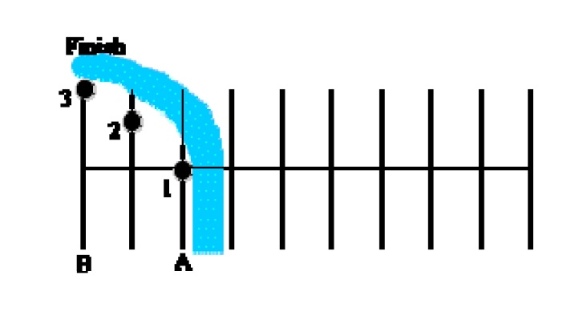
Coaching Tips
Keep head and eyes up; focus on where you want to go.
Straighten motorcycle, then apple both brakes stopping as quickly as possible.
Keep feet on pegs until almost stopped.
When stopped, the left foot should touch the ground first, and you should be in first gear.
Do not skid either wheel.
Problem Corrections
1. Overshooting the final marker. Apply more pressure to the brakes once motorcycle is straightened from the lean angle.
2. Motorcycle nearly falls over. Straighten up the motorcycle, and then apply the brakes. Be sure the handlebars are square with the motorcycle.
3. Rear wheel skids. Apply less pressure on the rear brake and make sure the motorcycle is straight up.
Exercise: Turning and Cornering
Directions
Practicing these drills will help you in turning and cornering at higher speeds such as curves on highways and winding roads, especially when the curve is tighter than you anticipated.
Ride to the left around the oval indicated by markers one, two, three, four, five and six. Adjust your speed and lean angle so that a small throttle opening is held steady through marker one, two and three. Repeat the drill turning to the right.
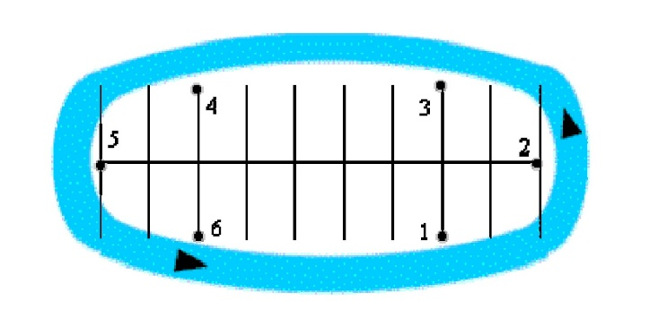
Coaching Tips
Beginning speed of 10-15 mph.
Slow down before the turn.
Look through the turn to where you want to go. Lean with the motorcycle.
Hold a steady speed or roll on the throttle gently through the turn.
Problem Corrections
1. Swinging wide of the turn. Look for the exit point. Apply more pressure on the handlebar in the direction of the turn.
2. Cutting corners too close or turning too sharply. Look at the exit point. Do not look down. Apply less pressure to the inside handlebar.
3. Exiting wide out of the turn, making the oval into a circle. Look where you want to go. Apply more pressure to the inside handlebar.
Exercise: Normal Stop on a Curve
Directions
Practicing this exercise will help you stop smoothly in a curve. Ride to the outside of line "A". As you reach marker one, turn in the curved path indicated by markers two, three, and four. Once you enter the curved path, gradually apply both brakes and downshift. Do not release the clutch. Try to come to a smooth stop with your front tire next to marker four. Do this at 10 mph, then 15 mph.
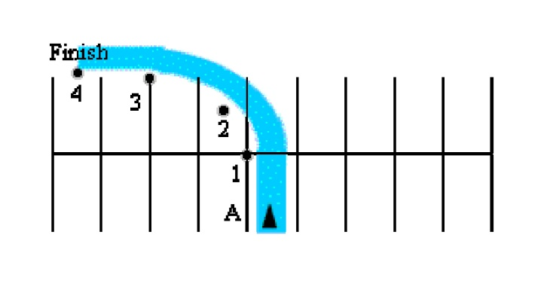
Coaching Tips
Keep head and eyes up; focus on where you want to stop.
Straighten up the motorcycle before you stop completely.
Use both brakes to stop.
Keep feet on pegs until almost stopped.
When stopped, the left foot should touch the ground first, and you should be in first gear.
Don't skid either tire.
Problem Corrections
1. Overshooting the final marker. Apply more pressure to the brakes once motorcycle is straightened from the lean angle.
2. Motorcycle nearly falls over. As soon as you begin stopping, decrease your lean angle. Straighten up the motorcycle, and apply more pressure to the brakes. Before stopping be sure the handlebars are square with the motorcycle.
3. Rear wheel skids. Apply less pressure on the rear brake and make sure the motorcycle is straight up.
Exercise: Sharp Turns
Directions
Practicing these drills will help you to make sharp turns from stoplights or stop signs, pulling out of parking spaces or driveways, and turning into a driveway, and turning into a driveway or onto a narrow street.
Drill 1 - Begin riding straight across the parking lot, increasing speed to approximately 10 mph. Just before reaching the "Begin Turning" Marker, slow down and use both brakes to adjust your speed for making a sharp turn. As you reach the line or marker make a sharp turn (left or right). Finish your turn as close to line "A" as you can without touching it. Remember to accelerate slightly coming out of the turn.
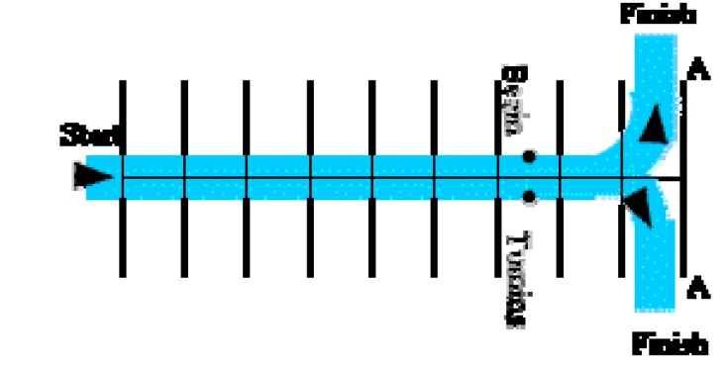
Drill 2 - Start at the marker. Begin making a sharp turn from the starting point. Finish your turn as close to line "A" as you can without hitting it.
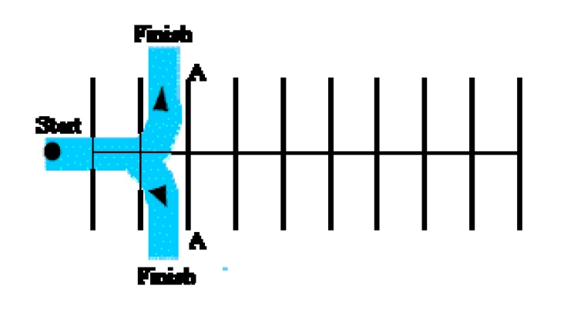
Coaching Tips
Keep head and eyes up; look where you want to be at the end of the turn.
Turn the handlebars and lean the motorcycle in the direction of the turn.
Use the friction zone of the clutch as you turn.
Accelerate as you leave the turn.
Cover the rear brake, and use both brakes lightly to reduce speed before the turn.
Practice left and right turns.
Problem Corrections
1. Turning too short or too long. Keep eyes up and look through the turn. Don't look down.
2. Not sure when or where to turn. Start your turn when the front wheel passes the start marker. As you start your turn, turn your head and look to the exit point. Do not look down.
3. Motorcycle stalls of falls into the turn. Concentrate on maintaining steady speed or slight acceleration.
Exercise: Normal Stop, Straight
Directions
Practicing this exercise will help you stop smoothly, such as for stoplights and stop signs.
Accelerate straight ahead across the parking lot between 15-20 mph (shift to second gear.) Begin to slow down and downshift at the first marker. Try to come to a smooth non-skidding stop with your front tire next to the last marker.
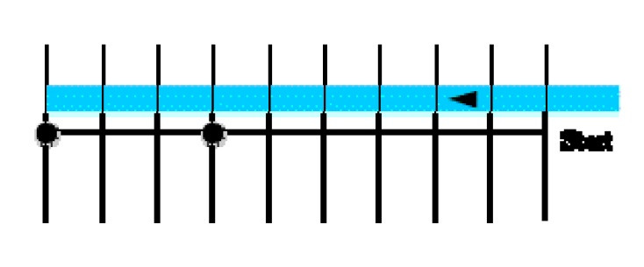
Coaching Tips
Keep head and eyes up.
Keep the motorcycle on a straight course.
Begin downshifting and braking at the first marker.
When stopping, roll off the throttle, squeeze in the clutch, downshift to first gear and apply both brakes smoothly, gradually applying more pressure.
Do not release the back brake until you come to a complete stop.
When stopped, the left foot should touch the ground first; your right foot should be applying the rear brake. You should be in first gear, ready for a quick escape if needed.
Problem Corrections
1. Rear wheel skids. Apply less pressure on the rear brake.
2. Overshooting marker. Begin slowing and braking sooner.
Exercise: Quick Stop, Straight
Directions
Practicing this exercise will help you stop quickly when something suddenly appears in your path.
Approach marker one, shifting up to second gear. As your front tire passes marker one, roll off the throttle, squeeze in the clutch lever, downshift to first gear and gradually apply both brakes to begin braking. Try to stop before marker two. Practice this at 10 mph, then 15 mph, then 20 mph. Do not exceed 20 mph.
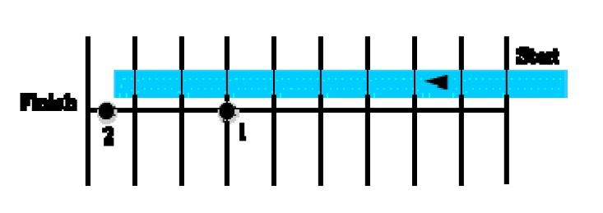
Coaching Tips
Keep your head and eyes up and looking forward.
When stopping, roll off the throttle, squeeze in the clutch, downshift to first gear and apply both brakes smoothly, gradually applying more pressure.
Do not release the clutch.
Keep the handlebars squared and the front wheel straight.
Do not release the rear brake until fully stopped.
Try to stop before the second marker.
When stopped, the left foot should touch the ground first; your right foot should be applying the rear brake. You should be in first gear, ready for a quick escape if needed
Try to stop before the second marker.
Problem Corrections
1. Overshooting the final marker. Gradually apply more pressure to brakes. Avoid locking the brakes. If you lock the front brake, release and reapply.
2. Motorcycle slides sideways. Sit straight on seat and do not turn handlebars, look straight ahead. It is okay to lock the rear wheel if the motorcycle is going straight.
3. Engine over revs when using the front brake. Keep and wrist in a flat position when you grip the throttle. This will aid the throttle to brake lever transition and reduce inadvertent throttle roll-on. Close the throttle before braking. Avoid pulling back on the throttle when applying pressure to the front brake. Squeeze the front brake with four fingers.
Exercise: Weaves
Directions
Practicing these drills will help you in making quick lane changes in traffic or changes in direction.
Drill 1 - 30-foot Weave - Begin at one end of the parking lot lines or markers. Go to the right of the first marker, left of the second, right of the third, and so on.
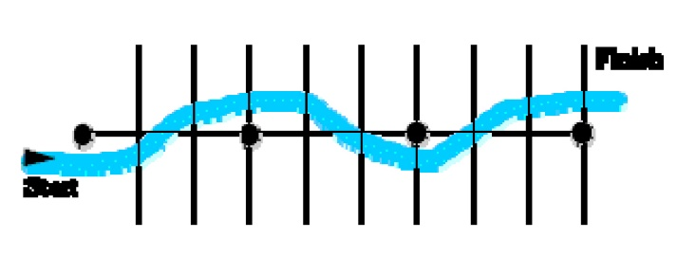
Drill 2 - 20-foot Weave - Proceed the same as you did in the 30-foot weave.
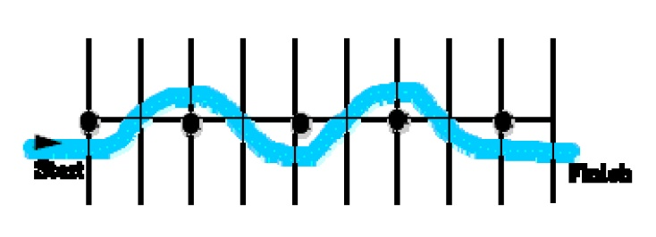
Coaching Tips
Keep head and eyes up. Avoid looking down; use your peripheral vision to locate the markers.
Turn by pushing on the handlebars in the direction of the turn. (Push right to go right; push left to go left.)
Lean with the motorcycle for the exercise.
Maintain a steady speed.
Problem Corrections
1. Swinging too wide away from the markers. Look past the last marker, decrease lean angle and push less on the handlebars.
2. Hitting markers. Look past the last marker, increase lean angle slightly and push more on the handlebars.
Exercise: Obstacle Swerve
Directions
Practicing this exercise properly will help you swerve to avoid a potential hazard. Approach the first pair of markers. As you reach the markers you should be going 10-15 mph. Make sure you've decided on which direction you intend to go before starting the exercise. As your front tire passes the first pair of markers, swerve to the right or left. Go to the outside of the next marker but try not to cross line "A" or "B". Do not stop; continue at a steady speed and repeat the exercise.
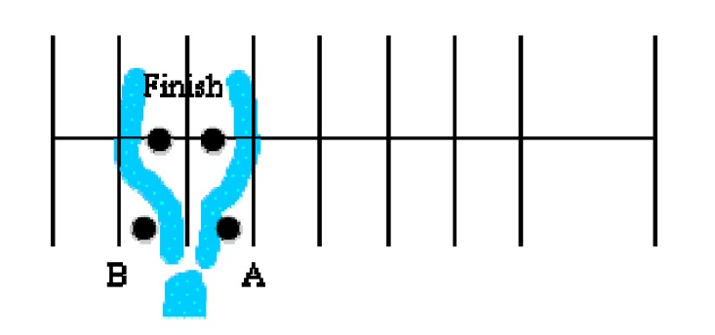
Coaching Tips
To swerve right, push right until you have cleared the marker, then push left to resume straight ahead travel.
Push on the handlebar in the same direction you want to go. (Push right to go right, push left to go left.)
Do not brake and swerve at the same time.
Problem Corrections
1. Unable to properly complete the swerve. Maintain pressure on the handlebar until you have cleared the marker. Avoid looking down; look where you want to go.
Exercise: Higher Speed Turns
Directions
Start, facing marker one at a distance sufficient enough to increase your speed to 10-15 mph. Just before reaching the end of line "A", reduce speed by applying both brakes. Start at point 1. As you start your turn at point 1, look to the exit point and gradually roll on the throttle throughout the turn. Practice turning in both directions.
Coaching Tips
Avoid looking down.
Do not squeeze the clutch lever.
Avoid applying the brakes when the motorcycle is leaned over.
Look through the turn where to your exit where you want to go.
Beginning speed of 10-15 mph. Lean with the motorcycle.
Slow down before the turn by applying both brakes smoothly.
Gradually increase speed throughout the turn.
Problem Corrections
1. Swinging wide of the turn. Look to the exit point and push more on the inside handlebar.
2. Cutting corner too close or turning too sharply. Do not look down. Look at the exit point. Gently roll on the throttle to stabilize the suspension.
3. Exiting wide out of the turn, making the oval into a circle. Slow down more before entering the turn, look to the exit point, push more on the inside handlebar and gently roll on the throttle.
Remember to know your motorcycle and know your limitations. Increased practice, increased skills, and increased awareness can help lead to increased driving safety.
This practice guide was brought to you by Don Moore, Montgomery County Harley Owner's Group Safety Officer.

